Automate Process for AAD user creation and adding to AAD Group (License group)

Purpose – To Create User in Azure Active Directory & Assign licenses to Azure AD users using Power Automate.

Plan – To automate this process, we use a flow in Power Automate flow, which triggers whenever any item is created in the SharePoint list.

first, we need a SharePoint site, for filling in users’ details, which is mandatory to create a user.

And an azure security group for license assignment.

**Entire Flow –**

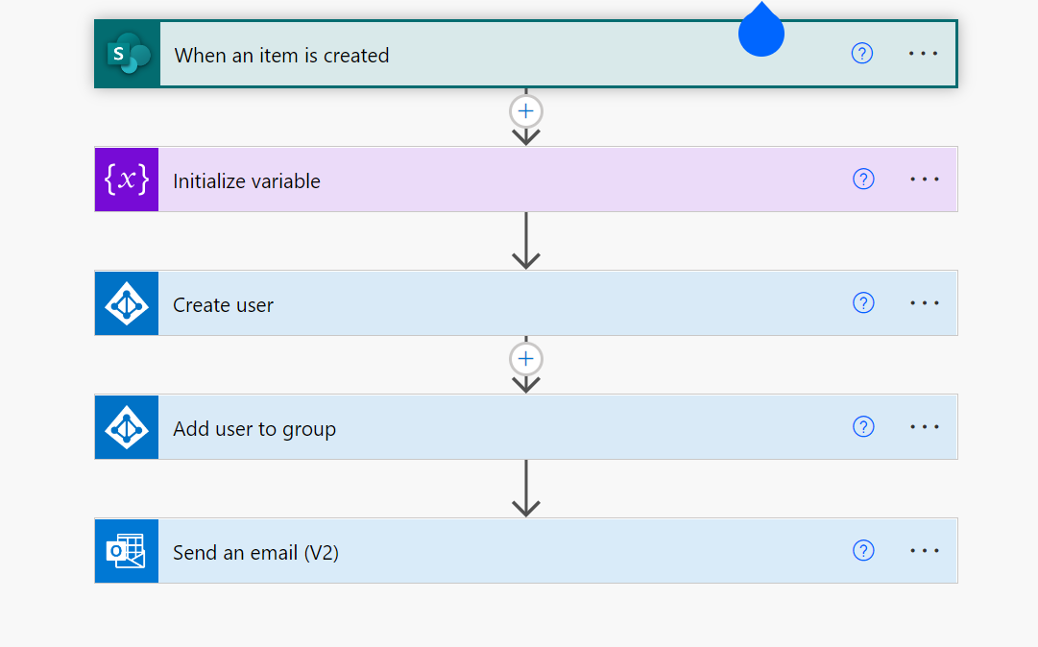

Let’s get started-

Step 1 – We will create a cloud automated flow that will trigger whenever a new item is created in SharePoint.

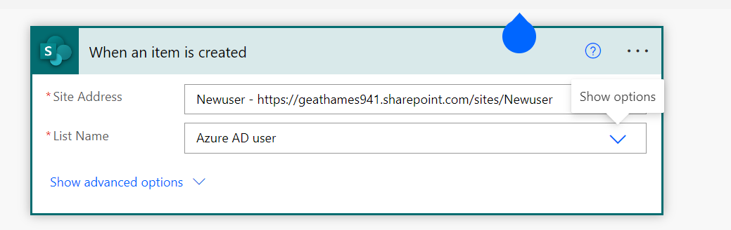

SharePoint list –

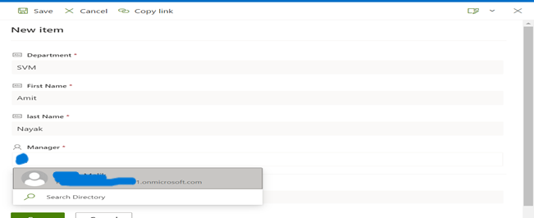

Step 2- To assign a random password for users, we must initialize a variable.

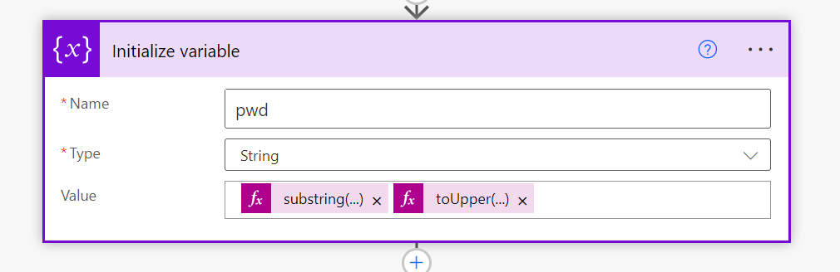

Step 3 -Search for Azure AD connector and select Create user action.

**Fill in the following parameter**

* + Account Enabled: Yes
  + Display Name: FirstName + Last Name
  + Mail Nickname: FirstName
  + Password: Generate Random Password
  + User Principal Name: UserName@domainName.com
  + Given Name: User FirstName
  + Surname: User Last Name

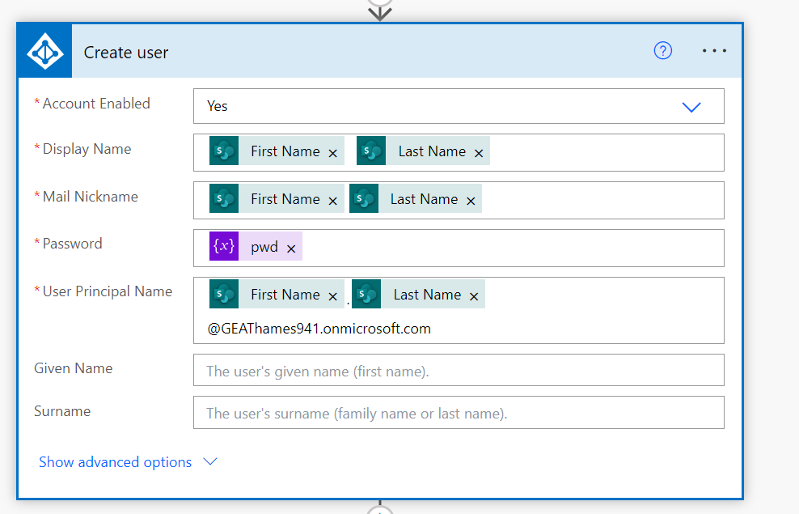

**For group-based licensing, we have created a security group for license assignments.**

**Create License Group in Azure Active Directory**

* [Login to Azure.](https://portal.azure.com/)
* Go to Azure Active Directory
* Go to Groups

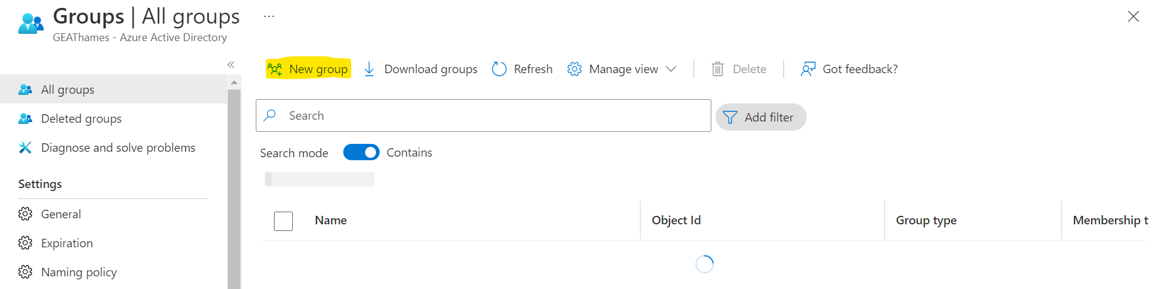

* 1. Group type: Security
  2. Group name: Enter the name of your group
  3. Click on Create.
  4. Open your newly created group
  5. Copy the Object Id of the group (we require this in power automate)
  6. Go to Licenses
  7. Click on “+Assignments”
  8. Select the licenses which you want to assign and click on save.
  9. Your group has the license now.

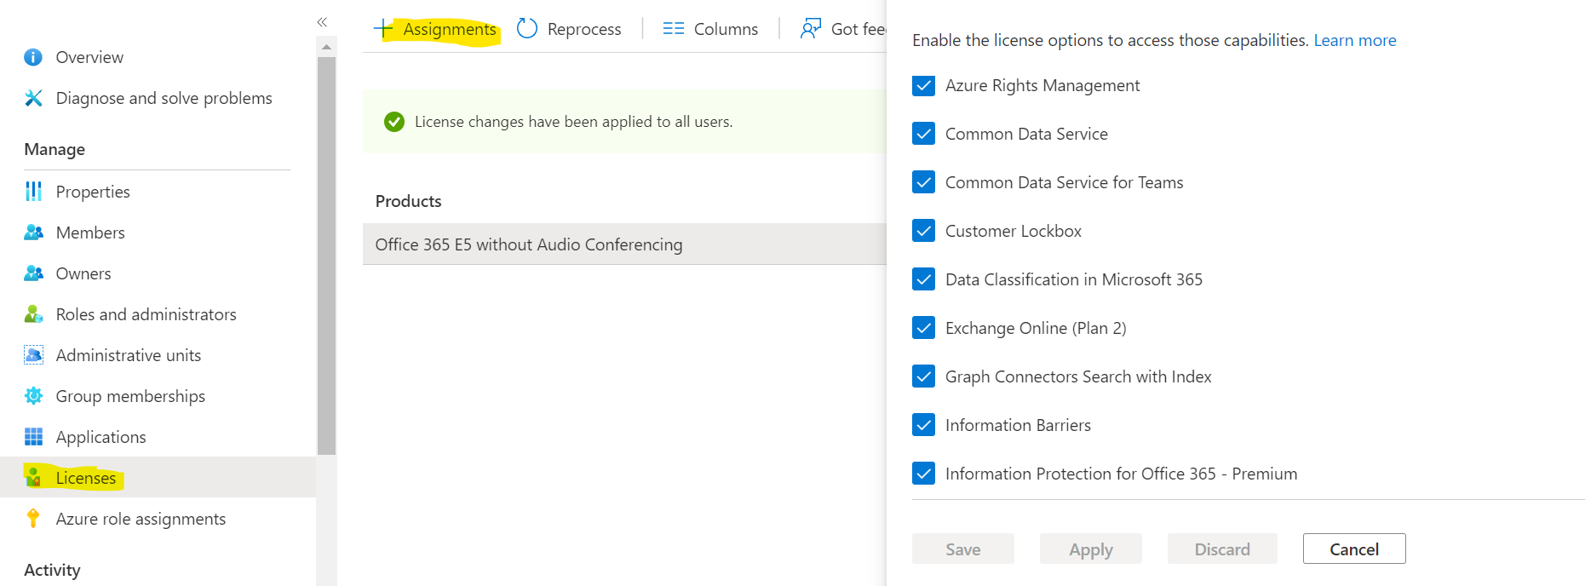

We have successfully created a group and assigned licenses to that group.

On adding users by default, they will get licenses.

Step 4 - Search for Azure AD connector and select “Add user to group” action

1. Enter group ID
2. User ID, we will pick up from dynamic content

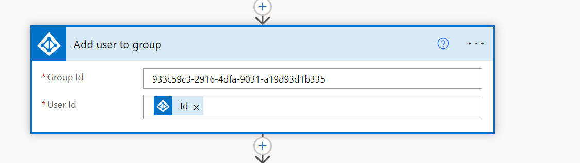

Step 5 – Share the details by email

